**Leaders | Crunch time**

**社论|能源短缺之困**

(英文部分选自经济学人20220806社论版块)

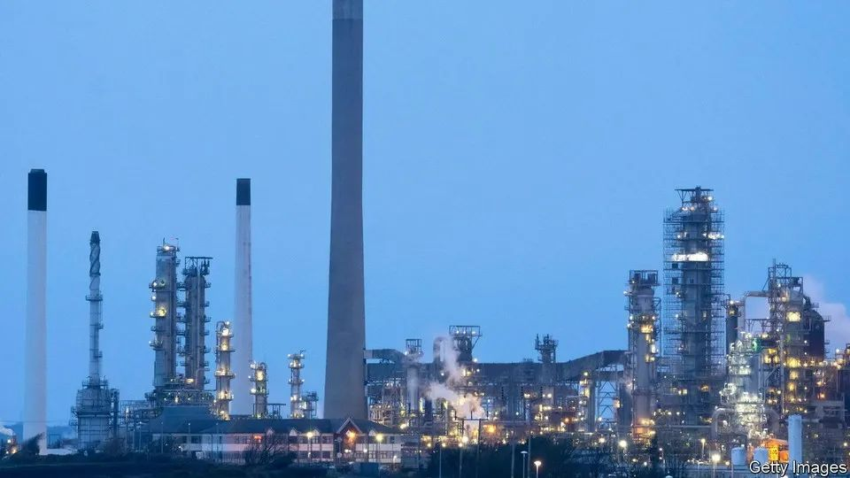

Leaders | Crunch time

社论|能源短缺之困

How to help with **energy bills**

如何应对**能源价格**危机？

**There are better, fairer and cheaper ways than meddling with prices**

**相比价格干预，有更好、更公平和更经济的应对措施**

**【①擅用there be句型，但CE，不翻出there；②than的翻译，可以考虑新思路——“相比……，有更……的……”】**

**The energy crisis unleashed by Russia’s war on Ukraine is crushing Europe’s consumers and panicking its politicians**. Natural-gas prices are eight times higher than they were last summer and traders expect precious little respite **over the coming year**. Global oil prices are nearly twice their level in January 2021. The result is **rampant rises** in living costs. **{ By October** a household in Britain **could be** paying more than £3,500 ($4,200) a year for energy, more than three times last year’s bill, **leading the Bank of England to warn of** inflation passing 13% **before the year is out**. **}** **Annual consumer-price** inflation rates are already in double digits in half of the euro area’s member countries.

**俄乌战争引发的能源危机正使欧洲消费者不堪重负，欧洲各国政界人士深感恐慌【①“俄乌战争引发的”前没有“由”②“正使”把“is doing”表达出来了，也是is doing的一种翻译方式，变主动】**。欧洲目前的天然气价格飙升至去年夏天的九倍，能源商预计，**未来一年**价格下降的可能性甚微。另一方面，全球油价接近2021年1月的两倍。这造成的后果是生活成本**急剧上升**。**{预计到今年10月**，英国家庭的年能源开支**可能**超过3500英镑（4200美元），超过去年的三倍。**因此英格兰银行发出警告**，**在今年年底之前**，通胀率或将超过13%。**}**在半数欧元区成员国中，**年度消费价格**通胀率已经达到两位数。

**Alas, politicians are botching their response**. To stop rising wholesale energy prices **passing through** fully to consumers’ bills, many have **resorted to price caps** and **energy-tax reductions**. Liz Truss, a Conservative politician vying to become Britain’s next prime minister, **is talking of** cutting payroll taxes. But price ceilings **do nothing to** reduce energy use and tax cuts will not protect the poorest. **With no immediate end to the crunch in sight, it is time for some hard-headed thinking about how to live with higher energy bills**.

**然而，欧洲各国政府的应对却有些笨拙**。为防止不断上涨的能源批发价**完全转嫁**到消费者头上，许多国家采取了**限价**和**削减能源税**的措施。正在竞逐英国下任首相的保守党人利兹·特拉斯（Liz Truss）**呼吁**削减工资税。但是限价对减少能源使用量**没有任何作用**，减税也无法保护最为贫困的群体。**眼下能源危机还没有结束的迹象，是时候冷静地思考如何应对越来越高的能源价格了**。

**The cheapest protection** is to trade natural gas **across national borders**, which IMF modelling suggests could nearly halve the blow to GDP in the worst-affected countries. **Next, within domestic markets, price signals have a vital role to play in curbing demand and ensuring that precious gas gets to where it is most needed**. Ceilings on the price of natural gas used by **power generators**, **as in Spain and Portugal**, or a cap on household bills, as in France, may serve as emergency measures when a shock is fleeting. But today’s scarcity **is likely to be** **long-lasting**. Consumers and businesses need to adapt.

**最为经济的应对措施**是进行**跨国**天然气交易。据国际货币基金组织的模型预测，对于受能源危机影响最严重的国家，这可能使其GDP受到的影响减半。**其次，在国内市场，价格信号发挥着至关重要的作用，它能够抑制需求并确保宝贵的天然气用到最急需的地方。【①对next的翻译；②对with的翻译；③对have a vital role to play in…的翻译分成两个分句，可以进行回译】像西班牙和葡萄牙那样**【**对“as/像”的翻译**】，对**发电厂**使用的天然气价格设置上限，或者像法国那样，对家庭能源开支设置上限，这些都可以成为短暂能源危机中的救急措施。但当下的能源紧缺**可能是长期的**，消费者和企业需要适应。

**Hearteningly**, **there are signs that** people and businesses can and do respond to high prices by conserving energy. They are also more resilient than fearful governments might think. In Germany farmers and industrialists are importing more ammonia and other energy-intensive chemicals, rather than relying on dearer domestically produced inputs. Studies suggest that both German households and firms have reduced their consumption of natural gas since mid-2021.

**令人鼓舞的是【副词放句首，可以译成“令人……”】**，**有迹象表明**，百姓和企业可以通过节约能源来应对能源价格上涨，而且他们已经在这样做了。他们的适应能力比忧心忡忡的政府所预想的更为强大。在德国，由于本土生产成本高涨，农场主和实业家们正在加大进口氨气和其他制备过程耗能极高的化学品。研究表明，自2021年年中以来，德国家庭和企业的天然气消耗量均有所减少。

Sometimes conservation can be galvanised by **regulation**. Spanish businesses and shops now **go dark** after 10pm, and the air-conditioning standards for public and commercial buildings are set at a minimum of 27°C, to encourage Spaniards to go shopping in their t-shirts. **Likewise**, energy companies can help change behaviour by telling people how much energy they use compared with their neighbours. Such interventions are cheap (though some have the drawback of muffling price signals), and can help defuse the incendiary politics of high prices. **Affecting rich and poor alike, they are seen as fair**.

**管控措施**有时也有助于节约能源。如今在西班牙，企业和商店在晚上10点后就会**熄灯**，公共和商业场所的空调温度不得低于27摄氏度，这是鼓励人们穿T恤去购物。**同样**，能源公司可以告知消费者他们与邻居的耗能对比，从而影响他们的能源使用方式。这些干预措施不花多少钱（尽管有些措施有抑制价格信号这一缺点），并且有助于缓和针对能源价格过高的煽动性政治活动。**这些措施对富人和穷人均产生同等影响，因此被认为是公平的【对“alike/同等”的翻译】**。

But governments also need to protect those most in need, notably poor people, for whom energy bills make up a bigger share of household spending. **Politicians cannot stop rising energy prices from making economies worse off**, but they can determine who bears the brunt of the shock. Support, in the form of rebates on energy bills for the poorest, or even cash bonuses (as recently enacted in Italy), would help the neediest, while still encouraging consumers to conserve energy where they can.

但政府同时需要保护那些最需要保护的人，尤其是穷人，他们的能源支出占家庭总支出的比例更大。**政客们无法控制能源价格上涨对经济造成的负面影响【对“cannot stop… from…”的翻译】**，但可以决定谁将承受主要的冲击。退还部分能源费用，甚至是给予现金补贴（最近在意大利开始实行），可以帮助到最贫困的人口，同时可以鼓励消费者尽可能节约能源。

Targeting **is essential to keep the cost in check**. According to the IMF, some European governments are **on course to** spend 1.5% of GDP on energy policies by the end of the year. Measures that protect the poorest fifth of the population would cost only 0.4% of GDP; the poorest two-fifths, 0.9%. **Trying to buy support by including everyone is a bad use of public money**

选择目标人群是**控制成本的关键**。据国际货币基金组织的数据，一些欧洲国家到今年年底很可能投入GDP的1.5%到能源政策上。实际上，如采取旨在保护最贫困的20%人口的措施，只需投入GDP的0.4%；如保护最贫困的40%人口，则需投入GDP的0.9%。**为收买民心而推行惠及所有人的政策，这纯粹是浪费公帑**。

**Windfall pitfall**

课税有讲究 横财切勿夺

Who, then, should pay? The **crowd-pleasing** choice is the energy companies, which are **making out** like bandits, but general taxation makes more sense. Windfall taxes on energy producers are undesirable if their fortunes follow the boom and bust of the commodities cycle. That only leads to underinvestment—and the next bout of sky-high prices.

那么，究竟谁该承担成本呢？若**要大众满意**，应当让能源公司来承担，因为他们在这场能源危机**中大发横财**，但更为合理的做法是对他们按常规课税。如果能源生产商的收入随着能源价格周期起起落落，对他们征收暴利税并不可取，反而只能导致投资不足，并引起新一轮的能源价格暴涨。